1. *DNS is the root of the internet that translates the domain name to IP Address and vice versa.*
2. *Example: If we type www.unixmen.com in browser, the DNS server translates the domain name into its associated ip address.*
3. *DNS servers are used to translate the hostnames like www.google.com to 108.162.219.71.*

***DNS Server***

*Operating System : Centos*

*Hostname : a.deep.com*

*IP Address : 192.168.72.80*

***B Details***

*Operating System : Centos*

*Hostname : b.deep.com*

*IP Address : 192.168.72.81*

***Now Install bind9 packages on your DNS server***

*yum install bind bind-utils -y*

***Now edit in file***

*vi /etc/named.conf*

*options {*

*listen-on port 53 { 127.0.0.1; 192.168.72.80; };*

*listen-on-v6 port 53 { ::1; };*

*directory "/var/named";*

*dump-file "/var/named/data/cache_dump.db";*

*statistics-file "/var/named/data/named_stats.txt";*

*memstatistics-file "/var/named/data/named_mem_stats.txt";*

*recursing-file "/var/named/data/named.recursing";*

*secroots-file "/var/named/data/named.secroots";*

*allow-query { localhost; 192.168.72.0/24; };*

*};*

*logging {*

*channel default_debug {*

*file "data/named.run";*

*severity dynamic;*

*};*

*};*

*zone "." IN {*

*type hint;*

*file "named.ca";*

*};*

*zone "deep.com" IN {*

*type master;*

*file "fwd.deep";*

*allow-update { none; };*

*};*

*zone "72.168.192.in-addr.arpa" IN {*

*type master;*

*file "rvs.deep";*

*allow-update { none; };*

*};*

*include "/etc/named.rfc1912.zones";*

*include "/etc/named.root.key";*

***Create Zone files***

***Create forward and reverse zone files which we mentioned in the /etc/named.conf file.***

***Create fwd.deep file in the /var/named directory.***

*vi /var/named/fwd.deep*

*Now Add these lines*

*$TTL 86400*

*@ IN SOA a.deep.com. root.a.deep.com. (*

*2011071001 ;Serial*

*3600 ;Refresh*

*1800 ;Retry*

*604800 ;Expire*

*86400 ;Minimum TTL*

*)*

*@ IN NS a.deep.com.*

*@ IN NS b.deep.com.*

*a IN A 192.168.72.80*

*b IN A 192.168.72.81*

***Create rvs.deep file in the /var/named directory.***

*vi /var/named/rvs.deep*

*Now Add these lines below*

*$TTL 86400*

*@ IN SOA a.deep.com. root.a.deep.com. (*

*2011071001 ;Serial*

*3600 ;Refresh*

*1800 ;Retry*

*604800 ;Expire*

*86400 ;Minimum TTL*

*)*

*@ IN NS a.deep.com.*

*@ IN NS b.deep.com.*

*a IN A 192.168.72.80*

*b IN A 192.168.82.81*

*80 IN PTR a.deep.com.*

*81 IN PTR b.deep.com.*

*There are some special keywords for Zone Files*

*A – A record*

*NS – Name Server*

*MX – Mail for Exchange*

*CNAME – Canonical Name*

*PTR – Pointer*

*SOA – Start of Authority*

***Check DNS configuration and zone files for any syntax***

*named-checkconf /etc/named.conf*

*named-checkzone deep.com /var/named/fwd.deep*

*named-checkzone deep.com /var/named/rvs.deep*

***(It should be Ok)***

***Add the Host entry in /etc/hosts***

*vi /etc/hosts*

*192.168.72.80 a.deep.com a*

*192.168.72.81 b.deep.com b*

***Now add on each machine a DNS server ip address in /etc/resolv.conf***

*search deep.com*

*nameserver 192.168.72.80*

*nameserver 8.8.8.8*

*systemctl restart network*

*systemctl restart named*

*systemctl enable named*

***Allow firewall to let bs can connect to DNS server for name resolution***

*firewall-cmd --permanent --add-port=53/udp*

*firewall-cmd --reload*

***Check DNS Server***

*dig a.deep.com*

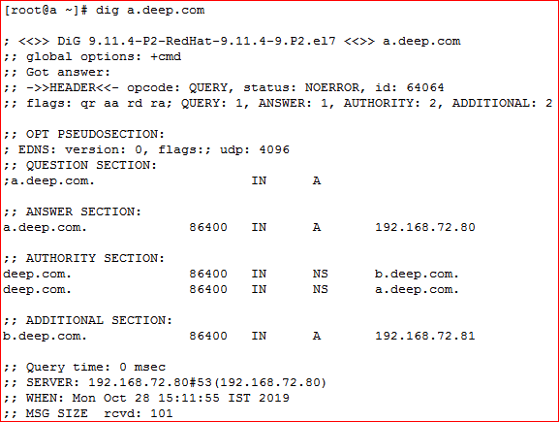

*nslookup a.deep.com*

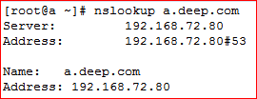

*nslookup b.deep.com*

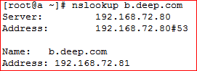

***On Client Side Configuration***

*yum install bind bind-utils -y*

***Add the DNS server details in /etc/resolv.conf file in all b systems***

*vi /etc/resolv.conf*

*search deep.com*

*nameserver 192.168.72.80*

*nameserver 8.8.8.8*

***Now Check DNS Server on client side***

*dig a.deep.com*

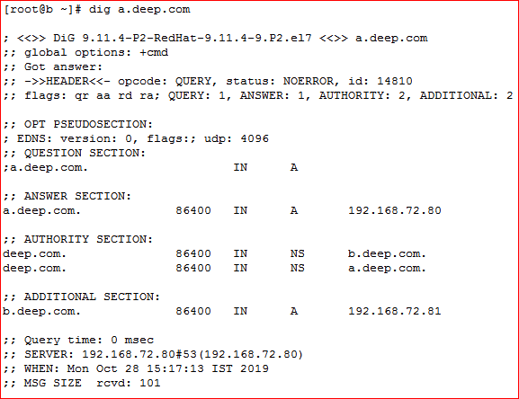

*nslookup a.deep.com*

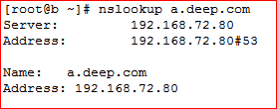

*nslookup 192.168.72.80,81*

